

Network Packet Analyzer and Traffic Monitoring Tool
A CAPSTONE PROJECT REPORT

A Capstone Project Report submitted in partial fulfilment of the requirements for the Course of

CSA0208 - C PROGRAMMING
to the award of the degree of

BACHELOR OF ENGINEERING

IN

ELECTRONICS AND COMMUNICATION ENGINEERING

Submitted by

SRIDHARSHAN S (192412311)

SARAVANA YOGESH M (192412273)

DINASH KUMAR S (192313001)
Under the Supervision of
DR. V. JAYASUDHA
SIMATS ENGINEERING
Saveetha Institute of Medical and Technical Sciences
Chennai-602105

SEPTEMBER 2026

SIMATS ENGINEERING
Saveetha Institute of Medical and Technical Sciences Chennai-602105

BONAFIDE CERTIFICATE

This is to certify that the Capstone Project entitled “Network Packet Analyzer and Traffic Monitoring Tool” has been carried out by SRIDHARSHAN S (192412311), SARAVANA YOGESH M (192412273) and DINASH KUMAR S (192313001) under the supervision of Dr. V. JAYASUDHA and is submitted in partial fulfilment of the requirements for the current semester of the B.Tech Electronics and Communication Engineering program at Saveetha Institute of Medical and Technical Sciences, Chennai.

COURSE COORDINATOR COURSE FACULTY
Dr. M. Shakila DR. V. JAYASUDHA,
Professor Assistant Professor
Computer Science and Engineering Computer Science and Engineering
SIMATS Engineering, SIMATS Engineering,
SIMATS, Chennai – 602105. SIMATS, Chennai – 602105.

SIMATS ENGINEERING
Saveetha Institute of Medical and Technical Sciences Chennai-602105

DECLARATION

We, SRIDHARSHAN S, SARAVANA YOGESH M, DINASH KUMAR S of the ELECTRONICS AND COMMUNICATION ENGINEERING, SIMATS Engineering, Saveetha Institute of Medical and Technical Sciences, Chennai, hereby declare that the Capstone Project Work entitled “Network Packet Analyzer and Traffic Monitoring Tool” is the result of our own bonafide efforts. To the best of our knowledge, the work presented herein is original, accurate, and has been carried out in accordance with the principles of engineering ethics and academic integrity. All sources, references, data, and other materials used in the project have been appropriately acknowledged. We further declare that the data, results, analysis, and findings presented in this report have not been fabricated, falsified, or manipulated. Any external tools, software, datasets, computational resources, or AI-assisted tools used during the project have been appropriately disclosed. We confirm that all applicable ethical, academic, institutional, and professional requirements have been duly followed throughout the planning, execution, analysis, and documentation of the project.

Place: Chennai
Date: 08-09-2026

Signature of the Students with Names

SIMATS ENGINEERING
Saveetha Institute of Medical and Technical Sciences Chennai-602105

Individual Contribution Statement

Student Name | Specific  Responsibilities | Design & Development Contribution | Testing & Analysis  Contribution | Report Contribution | Approx.  Contribution (%)
Sridhrshan S | Packet capture module design; interface selection logic; basic packet handling | Implemented core packet capture and buffering logic in C | Conducted packet-capture and Ethernet/IP parsing test cases | Chapters 1, 3, 5 | 33%
Saravana yogesh M | Protocol identification and header parsing (TCP/UDP/ICMP); integration | Implemented protocol classification and header-extraction functions; assisted with CLI integration | Conducted protocol identification, header extraction, and integration test cases | Chapters 2, 4 (4.2–4.3), References | 33%
Student 3 | Traffic statistics, filtering, logging, documentation, testing coordination, and project management | Implemented filtering rules and statistics aggregation; assisted with logging and project integration | Conducted filtering, statistics, high-traffic, and overall system testing; coordinated result compilation | Chapter 3 (3.6–3.7), Chapter 4 (4.4–4.8), Chapter 5, Appendices | 34%
Total |  |  |  |  | 100%

ABSTRACT
Modern computer networks carry increasingly large and heterogeneous volumes of traffic, and visibility into this traffic at the packet level is fundamental to network troubleshooting, performance evaluation, and security monitoring. Conventional manual inspection of network activity is impractical beyond small scales: administrators cannot manually trace individual packets, identify protocols, or detect anomalous patterns without tool support. While commercial and open-source packet analyzers such as Wireshark and tcpdump provide extensive capability, their complexity, resource requirements, and broad general-purpose feature sets can present a steep learning curve for students, researchers, and small-scale network operators who require a lightweight, focused, and customizable tool for education and basic monitoring.
This project addresses this engineering problem by designing and implementing a Network Packet Analyzer and Traffic Monitoring Tool using the C programming language, built around a packet-capture library (such as libpcap or an equivalent capture mechanism) for interfacing with the underlying network interface. The system is engineered as a pipeline comprising packet capture, Ethernet and IP header parsing, transport-layer protocol identification (TCP, UDP, ICMP), source/destination address and port extraction, packet-size computation, rule-based filtering, traffic-statistics aggregation, and console-based/log-based reporting of results. The methodology followed a structured engineering process consisting of requirement analysis, comparative evaluation of design alternatives, detailed design of the capture-and-analysis pipeline, modular implementation in C, and a verification-driven test plan covering protocol recognition accuracy, address/port extraction correctness, filtering behaviour, and handling of malformed packets and high traffic volumes.
The proposed tool is evaluated against defined functional and non-functional requirements, including packet-parsing accuracy, processing latency, and resource utilization. [INSERT ACTUAL TEST RESULTS] summarizing packet-capture counts, protocol-wise distribution, and measured processing performance are to be reported once experimental data collection is complete. Based on the design and the verification approach adopted, the tool is expected to provide functionally correct protocol identification and traffic-statistics reporting for common IPv4-based traffic within its defined scope, while acknowledging limitations such as the inability to inspect encrypted payloads and reduced suitability for very high-speed traffic capture without further optimization.
In conclusion, the project demonstrates that a lightweight, C-based packet analyzer can provide meaningful protocol-level visibility and traffic-monitoring capability for educational and small-scale operational use, while highlighting engineering trade-offs between simplicity, performance, and security that inform directions for future enhancement, including IPv6 support, anomaly detection, and graphical reporting.
Keywords: Network Packet Analyzer, Traffic Monitoring, Protocol Identification, Packet Capture, libpcap, Network Security

TABLE OF CONTENTS
Sl. No. | Title | Page No.
i | CERTIFICATE FROM THE SUPERVISOR | 2
ii | DECLARATION BY THE CANDIDATE | 3
iii | INDIVIDUAL CONTRIBUTION STATEMENT | 4
iv | ABSTRACT | 5
v | LIST OF FIGURES | 7
vi | LIST OF TABLES | 8
vii | LIST OF ABBREVIATIONS | 9
1 | CHAPTER 1: Introduction and Engineering Problem | 10
2 | CHAPTER 2: Literature Review and Existing Solutions | 14
3 | CHAPTER 3: Engineering Design & Trade-offs, Sustainability, Ethics, Safety, Risk & Security | 17
4 | CHAPTER 4: Implementation, Testing & Results, Project Management | 25
5 | CHAPTER 5: Conclusion, Future Work and Reflection | 31
 | References | 33
 | Appendices | 34
 | Capstone Project Outcome Mapping Sheet | 36

LIST OF FIGURES
Figure No. | Figure Name | Page No.
3.1 | Overall System Architecture | 20
3.2 | Packet Capture and Analysis Flowchart | 21
4.1 | Application Interface / Terminal Output | 26
4.3 | Protocol Distribution Graph | 27

LIST OF TABLES
Table No. | Table Name | Page No.
2.1 | Comparative Analysis of Existing Approaches | 15
3.1 | Stakeholder / User Requirements | 17
3.2 | Functional and Non-Functional Requirements | 17
3.3 | Constraints & Applicable Standards | 18
3.4 | Design Specifications | 19
3.5 | Alternative Design Evaluation Matrix | 19
3.6 | Trade-off Analysis | 22
3.7 | Sustainability, Ethics, Safety & Security Evaluation | 23
3.8 | Risk Register | 23
4.1 | Tools / Software Used | 25
4.2 | Test Plan & Verification | 28
4.3 | Protocol-wise Traffic Statistics | 28
4.4 | Performance Measurements | 30

LIST OF ABBREVIATIONS / SYMBOLS
Symbol | Description | Unit
IP | Internet Protocol | —
TCP | Transmission Control Protocol | —
UDP | User Datagram Protocol | —
ICMP | Internet Control Message Protocol | —
DNS | Domain Name System | —
HTTP | Hypertext Transfer Protocol | —
HTTPS | Hypertext Transfer Protocol Secure | —
MAC | Media Access Control | —
NIC | Network Interface Card | —
LAN | Local Area Network | —
WAN | Wide Area Network | —
PCAP | Packet Capture | —
IDS | Intrusion Detection System | —
DoS | Denial of Service | —
CLI | Command Line Interface | —

CHAPTER 1 INTRODUCTION AND ENGINEERING PROBLEM

1.1 Background
Computer networks form the backbone of nearly all modern computing activity, carrying data between hosts using layered protocols defined by the TCP/IP reference model. As the volume, diversity, and speed of network traffic have grown, the ability to observe and interpret this traffic at the packet level has become an essential engineering capability rather than an optional convenience. A network packet is the fundamental unit of data transfer, encapsulating addressing, protocol, and payload information across the Ethernet, IP, and transport layers.
Packet-level visibility underlies a broad range of engineering activities: diagnosing connectivity faults, characterizing bandwidth utilization, verifying that applications communicate using expected protocols, and detecting traffic patterns indicative of misconfiguration or malicious activity. Network monitoring — the continuous or periodic observation of traffic passing through an interface — and packet analysis — the detailed inspection of individual packets' headers and, where permissible, payloads — are complementary techniques that together give network administrators and security analysts the evidence needed to make informed decisions.
From a cybersecurity standpoint, packet analysis is particularly significant: many classes of network attacks, including denial-of-service attempts, port scanning, and protocol misuse, manifest as observable irregularities in packet headers, traffic volume, or protocol distribution before they escalate into more serious incidents. Abnormal network traffic — whether caused by faulty hardware, misconfigured software, or malicious actors — can degrade performance, compromise confidentiality, or disrupt availability. Packet analyzers therefore serve a dual engineering role: as diagnostic instruments for troubleshooting and as early-warning instruments for security monitoring.
This project situates itself within this context by proposing the design and development of a lightweight, C-based Network Packet Analyzer and Traffic Monitoring Tool intended to capture live network traffic, identify protocols in use, extract addressing and size information, compute traffic statistics, and support basic filtering and logging — providing a hands-on engineering illustration of the principles that underpin professional-grade tools such as Wireshark and tcpdump.

1.2 Need for the Project
Continuous or on-demand traffic monitoring is needed because network behaviour changes dynamically, and problems — whether performance-related or security-related — are frequently transient and difficult to reproduce after the fact without captured evidence. Several stakeholder groups are directly affected by the availability (or absence) of accessible packet-analysis tooling:
- Network administrators, who require quick, low-overhead visibility into traffic passing through managed interfaces for fault diagnosis.
- Students and researchers, who need an approachable, modifiable implementation through which to study protocol behaviour rather than a closed, feature-heavy commercial tool.
- Small organizations and individual system operators, who often lack the budget or staffing for enterprise-grade network monitoring infrastructure.
- Security analysts, who require protocol-level and statistical evidence to identify early indicators of suspicious traffic.
Existing general-purpose tools such as Wireshark provide comprehensive capability but present a correspondingly steep learning curve, a large codebase that is difficult to extend for teaching purposes, and resource overheads that are not always justified for narrowly scoped monitoring tasks. There is consequently a recognized need for a lightweight, customizable, and pedagogically transparent packet-analysis implementation whose internal logic (capture, parsing, classification, filtering, statistics) is fully visible and modifiable by its users — which constitutes the engineering and educational significance of this project.

1.3 Problem Statement
Designing a network packet analyzer that reliably captures live traffic from a network interface, correctly parses multi-layer packet headers (Ethernet, IPv4, and transport-layer protocols including TCP, UDP, and ICMP) under varying traffic loads, and produces accurate, low-latency traffic statistics and filtered output is a multi-factor engineering problem. It requires balancing (a) packet-capture completeness against processing overhead and potential packet loss at higher traffic rates, (b) protocol-parsing accuracy against the complexity of handling malformed or non-standard packets, (c) the utility of detailed per-packet information against the privacy and security implications of capturing and storing network traffic content, and (d) the resource constraints of a lightweight, single-machine implementation against the functional completeness expected of a useful monitoring tool. The problem is bounded to capture and analysis of unencrypted header information and traffic metadata for IPv4-based traffic on a single monitored interface; it explicitly excludes decryption of encrypted payloads, distributed multi-node monitoring, and enterprise-scale intrusion detection.

1.4 Project Aim
The aim of this project is to design and implement a lightweight, C-based Network Packet Analyzer and Traffic Monitoring Tool capable of capturing live network traffic, identifying protocols, extracting header-level information, computing traffic statistics, applying basic filtering rules, and reporting results in a form usable for network diagnostics, security awareness, and educational purposes.

1.5 Project Objectives
- To design a network packet capture and analysis system architecture suitable for a single monitored network interface.
- To develop a C-based packet processing module using libpcap (or an equivalent packet-capture mechanism) for live packet capture.
- To identify common network protocols (Ethernet, IPv4, TCP, UDP, ICMP) present in captured traffic with a target parsing accuracy of at least [TO BE MEASURED]% on captured test traffic.
- To extract relevant packet header information, including source/destination IP addresses, source/destination ports, and packet size, for each captured packet.
- To provide protocol-wise traffic statistics and near-real-time monitoring output during a capture session.
- To implement configurable packet filtering mechanisms (e.g., by protocol, source/destination address, or port).
- To evaluate system performance, including processing latency and packet-loss rate, using controlled test traffic of varying volume.
- To assess the usefulness, accuracy, and limitations of the proposed system relative to established tools such as tcpdump and Wireshark.

1.6 Scope

Included
- Live packet capture from a specified network interface.
- Parsing of Ethernet frames, IPv4 headers, and TCP/UDP/ICMP headers.
- Identification of protocol in use for each captured packet.
- Extraction of source/destination IP addresses and ports.
- Packet-size analysis and protocol-wise traffic statistics.
- Configurable, rule-based packet filtering.
- Traffic logging to a local file for later review.
- Near-real-time console-based monitoring output.

Excluded
- Full enterprise-grade Intrusion Detection System (IDS) functionality.
- Deep packet inspection of encrypted payloads (e.g., HTTPS/TLS content).
- Malware execution, detonation, or detection.
- Offensive network attacks or active traffic injection.
- Unauthorized interception of traffic on networks the user does not own or have explicit permission to monitor.
- Machine-learning-based intrusion or anomaly detection, unless actually implemented and evidenced in Chapter 4.

Assumptions and Boundary Conditions
- The tool is executed with the necessary operating-system privileges required for raw packet capture.
- Monitoring is performed only on networks/interfaces the student is authorized to observe (e.g., a personal lab or virtual network).
- IPv4 traffic is the primary addressing scheme considered; IPv6 support is treated as future work unless implemented.
- Traffic volumes used for testing are bounded by the capability of the development/test environment

1.7 Expected Engineering Outcome
The expected outcome of this project is a working software prototype — a command-line-based Network Packet Analyzer and Traffic Monitoring Tool implemented in C — capable of capturing live packets, classifying them by protocol, extracting addressing and size information, computing and displaying traffic statistics, applying user-defined filters, and producing log output suitable for subsequent review. The prototype is intended to serve as both a functional diagnostic utility and a demonstrable engineering artifact illustrating packet-capture and protocol-analysis principles.

CHAPTER 2 LITERATURE REVIEW AND EXISTING SOLUTIONS

2.1 Review Method
Relevant literature and existing technologies were identified through a review of official protocol documentation (RFC specifications for Ethernet, IPv4, TCP, UDP, and ICMP), the technical documentation of established packet-capture libraries (libpcap) and analyzer tools (Wireshark, tcpdump), and peer-reviewed and technical publications concerning network traffic monitoring and packet analysis methods. Search terms used to identify sources included combinations of “packet capture,” “network traffic analysis,” “protocol identification,” “libpcap,” and “network intrusion detection.” Sources were selected for relevance to packet-level analysis techniques, methodological transparency, and credibility (official standards bodies, established open-source project documentation, and peer-reviewed venues). [ADDITIONAL SOURCES / DATABASE NAMES TO BE FILLED BY STUDENT IF A FORMAL LITERATURE SEARCH WAS CONDUCTED].

2.2 Review of Existing Work
Wireshark is a widely used, open-source graphical packet analyzer that supports deep protocol dissection across hundreds of protocols. Its purpose is comprehensive, interactive traffic inspection; its method combines libpcap-based capture with an extensive dissector framework. Its principal advantage is analytical depth and usability for manual inspection; its principal limitation, from the perspective of this project, is that its scope and resource footprint exceed what is required for a focused, lightweight monitoring task, and its internal architecture is not intended to be studied or modified by beginner-level engineering students. It is relevant to this project chiefly as a verification benchmark during testing (Chapter 4).
tcpdump is a lightweight, command-line packet capture and display utility built directly on libpcap. Its purpose is fast, low-overhead packet capture and filtering using Berkeley Packet Filter (BPF) expressions. Its advantages include minimal resource usage and scriptability; its limitation is that it provides limited built-in aggregation or statistical reporting, requiring users to post-process its output for traffic statistics. This project adopts a similar lightweight, CLI-oriented philosophy while adding built-in protocol-wise statistics and filtering logic directly in the analyzer itself.
libpcap is the underlying cross-platform packet-capture library used by both Wireshark and tcpdump, and is proposed as the capture mechanism for this project. Its purpose is to provide a portable interface for capturing raw packets from network interfaces; its advantage is broad platform support and a mature, stable API; a limitation relevant to this project is that it provides only capture primitives, leaving parsing, classification, filtering, and reporting logic entirely to the application built on top of it — which is precisely the engineering work undertaken in this project.
Enterprise network monitoring systems and signature-based intrusion detection systems (IDS) offer more comprehensive traffic visibility and automated threat detection but are correspondingly complex to deploy, costly to license or maintain, and not designed for lightweight, single-host, educational use. Python/Scapy-based packet-analysis scripts offer a more approachable development experience than C but incur higher runtime overhead, a factor of direct relevance to the language-selection trade-off discussed in Chapter 3.

2.3 Comparative Analysis
Table 2.1 compares the reviewed approaches against the requirements of this project.
Existing Approach | Advantages | Limitations | Relevance to Proposed Work
Wireshark | Comprehensive protocol dissection; graphical interface; large protocol database; widely used and well documented | Heavyweight; steep learning curve for beginners; high resource usage for continuous monitoring; not easily embeddable/customizable for a focused task | Serves as a benchmark for protocol-parsing correctness and as a verification tool during testing
tcpdump | Lightweight command-line capture tool; low overhead; scriptable; widely available on Linux systems | Limited built-in statistical/analysis capability; output requires further parsing for structured traffic statistics | Demonstrates the value of a lightweight CLI-based approach, which this project adopts and extends with built-in statistics and filtering
libpcap-based custom tools (general) | Direct low-level access to packet capture; high performance; flexible for custom protocol logic | Requires manual implementation of parsing, filtering and reporting logic; higher development effort | Provides the underlying capture mechanism this project builds upon
Commercial Network Monitoring Systems (e.g., enterprise NMS platforms) | Scalable; feature-rich; often includes alerting, dashboards and historical reporting | High cost; complex deployment; not designed for single-host educational or lightweight use | Highlights the engineering gap this project addresses: a low-cost, single-host alternative for focused monitoring
Signature-based Intrusion Detection Systems (e.g., Snort-class tools) | Capable of automated rule-based threat detection; mature rule ecosystems | Requires maintained rule sets; primarily focused on threat detection rather than general traffic visibility; resource-intensive | Clarifies scope boundary: this project performs traffic analysis and basic anomaly flagging, not full IDS rule matching
Python/Scapy-based packet tools | Rapid development; readable syntax; strong prototyping support | Slower execution than compiled C for high packet rates; higher runtime overhead | Considered as Alternative 2 in the design evaluation in Chapter 3
Table 2.1: Comparative Analysis of Existing Approaches

2.4 Research / Engineering Gap
The reviewed tools collectively demonstrate that mature, capable packet-analysis software already exists; however, an engineering and educational gap remains in the availability of a lightweight, fully transparent, and easily extensible implementation whose internal capture-to-reporting pipeline is simple enough for an undergraduate team to design, implement, and reason about end-to-end. Specifically, the gap concerns: the complexity and resource requirements of professional-grade tools for narrowly scoped monitoring tasks; the learning curve associated with interpreting the output of general-purpose analyzers without first understanding the underlying protocol structures; limited customization of closed or large codebases for specific coursework or small-scale operational needs; and the absence, in many introductory settings, of a focused implementation that combines capture, parsing, filtering, and statistics reporting into a single compact tool. It is not claimed that existing tools are functionally incapable of the tasks addressed by this project — rather, that a purpose-built, lightweight alternative offers pedagogical and deployment advantages in the specific context this project targets.

2.5 Proposed Contribution
This project contributes a compact, C-based packet analyzer that integrates packet capture, multi-layer header parsing, protocol identification, address/port extraction, configurable filtering, and protocol-wise traffic statistics into a single lightweight tool, designed explicitly for transparency, modifiability, and low resource overhead rather than for comprehensive protocol coverage. Its contribution relative to the reviewed approaches lies in combining capture and structured statistical reporting within one focused implementation, at a scope suitable for educational use and small-scale monitoring, while explicitly excluding functionality (such as encrypted-payload inspection or full IDS rule matching) that would exceed the intended scope.

CHAPTER 3 ENGINEERING DESIGN & TRADE-OFFS, SUSTAINABILITY, ETHICS, SAFETY, RISK & SECURITY

3.1 Requirements

Stakeholder / User Requirements
Stakeholder | Requirement
Network Administrator | Requires quick identification of protocol-wise traffic volume and anomalous patterns on a monitored interface
Student / Researcher | Requires a transparent, modifiable implementation for studying packet structures and protocol behaviour
System Operator | Requires low-overhead monitoring that does not significantly impact host performance
Security Analyst | Requires accurate extraction of source/destination addressing and basic suspicious-traffic flags
Project Evaluator | Requires evidence of correct protocol identification, documented testing, and engineering justification of design decisions
Table 3.1: Stakeholder / User Requirements

Functional & Non-Functional Requirements
Requirement | Type | Measurable Target
Capture packets from a specified network interface | Functional | Successful capture of ≥ [TO BE MEASURED]% of packets under test load
Parse Ethernet, IPv4 and transport-layer headers | Functional | Correct field extraction on [TO BE MEASURED] test packets
Identify protocol (TCP/UDP/ICMP/other) | Functional | Protocol classification accuracy ≥ [TO BE MEASURED]%
Extract source/destination IP addresses and ports | Functional | Correct extraction verified against Wireshark reference capture
Calculate packet size | Functional | Size matches reference capture for [TO BE MEASURED] packets
Filter packets by protocol/address/port | Functional | Filter correctly includes/excludes packets per rule on test set
Display traffic statistics | Functional | Statistics updated at defined monitoring interval
Log traffic to file | Functional | Log file contains complete, readable entries for a capture session
Processing performance (latency per packet) | Non-functional (Performance) | ≤ [TO BE MEASURED] ms per packet under test load
Reliability (no crash during sustained capture) | Non-functional (Reliability) | No crash over a [TO BE MEASURED]-minute continuous capture session
Usability (clear CLI output) | Non-functional (Usability) | Output reviewed and confirmed legible by test users
Maintainability (modular code structure) | Non-functional (Maintainability) | Capture, parsing, filtering, and statistics implemented as separate modules
Portability (Linux compatibility) | Non-functional (Portability) | Successful build and run on target Linux distribution
Security (restrict access to captured data) | Non-functional (Security) | Log files created with restricted file permissions
Privacy (no payload content stored unnecessarily) | Non-functional (Privacy) | Only header/metadata fields logged by default
Table 3.2: Functional and Non-Functional Requirements

3.2 Constraints & Applicable Standards
The following standards and specifications directly govern the packet formats and library interfaces used in this project; standards not directly exercised by the implementation have been excluded rather than listed generically.
Standard / Code | Requirement | How Applied in This Project
IEEE 802.3 (Ethernet) | Correct interpretation of Ethernet frame structure for Layer-2 parsing | Ethernet header fields (destination MAC, source MAC, EtherType) parsed according to the standard frame format
IETF RFC 791 (Internet Protocol, IPv4) | Correct interpretation of IPv4 header fields | IPv4 header fields (version, header length, protocol, source/destination address) parsed per specification
IETF RFC 793 (Transmission Control Protocol) | Correct interpretation of TCP header fields | TCP header fields (source/destination port, flags) parsed per specification
IETF RFC 768 (User Datagram Protocol) | Correct interpretation of UDP header fields | UDP header fields (source/destination port, length) parsed per specification
IETF RFC 792 (Internet Control Message Protocol) | Correct interpretation of ICMP message types | ICMP type/code fields parsed for identification purposes
libpcap API documentation | Correct and portable use of packet-capture API | Capture loop implemented using documented libpcap function calls [VERSION TO BE FILLED BY STUDENT]
Applicable data-privacy principles (institutional policy) [TO BE VERIFIED] | Responsible handling of captured network data | Only traffic on networks the team is authorized to monitor was captured; payload content not stored by default
Table 3.3: Constraints & Applicable Standards

3.3 Design Specifications
Parameter | Target/Requirement | Unit | Priority
Packet capture rate | [TO BE MEASURED] | packets/sec | High
Processing latency per packet | ≤ [TO BE MEASURED] | ms | High
Packet parsing accuracy | ≥ [TO BE MEASURED] | % | High
Supported protocols | Ethernet, IPv4, TCP, UDP, ICMP | — | High
Filtering capability | By protocol, IP, port | — | Medium
Log storage | [TO BE MEASURED] | MB/session | Medium
CPU usage | [TO BE MEASURED] | % | Medium
Memory usage | [TO BE MEASURED] | MB | Medium
Monitoring/statistics refresh interval | [TO BE FILLED BY STUDENT] | sec | Low
Table 3.4: Design Specifications

3.4 Alternative Solutions & Evaluation
Alternative 1: A C-based packet analyzer using libpcap for capture, with all parsing, filtering, and statistics logic implemented directly in C.
Alternative 2: A Python-based packet analyzer using the Scapy library, offering faster prototyping at the cost of runtime performance.
Alternative 3: Configuration and scripted use of an existing tool (Wireshark/tcpdump) rather than developing new capture-and-analysis logic.
Each alternative was scored from 1 (poor) to 5 (excellent) against weighted criteria reflecting the project's non-functional requirements; weights reflect the relative importance of performance and customizability for the intended educational/lightweight monitoring use case.
Criterion (Weight) | Alt. 1: C + libpcap | Alt. 2: Python + Scapy | Alt. 3: Existing tool (config only)
Performance (30%) | 4.0 | 2.5 | 3.0
Cost (15%) | 5.0 | 5.0 | 3.0
Security (15%) | 3.5 | 3.0 | 4.5
Sustainability / resource use (15%) | 4.5 | 3.0 | 3.5
Reliability (10%) | 3.5 | 3.5 | 4.5
Customizability / learning value (15%) | 4.5 | 4.0 | 2.0
Table 3.5: Alternative Design Evaluation Matrix (scores 1–5, weighted)

3.5 Selected Design & Detailed Design
The selected design (Alternative 1) implements a linear capture-to-reporting pipeline in C using libpcap, structured as the following subsystems, each described with its input, processing role, output, and dependencies.

System Architecture
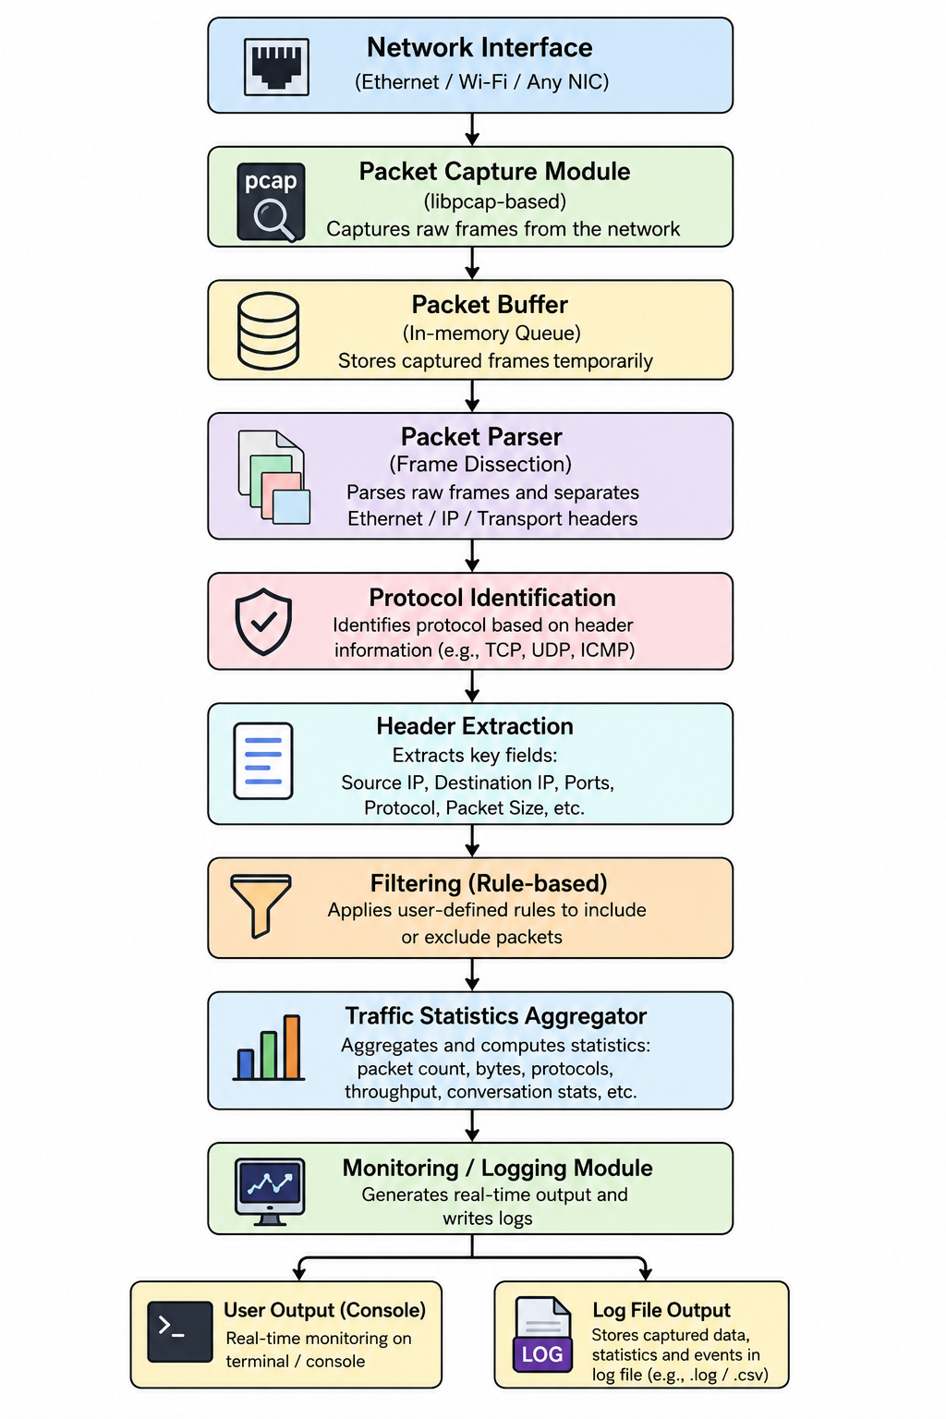
Figure 3.1: Overall System Architecture
Input: raw Ethernet frames from the selected network interface, obtained via the capture library in promiscuous or non-promiscuous mode as configured. Processing: sequential parsing of Ethernet, IP, and transport-layer headers; protocol classification; extraction of addressing/size fields; application of active filter rules; incremental update of per-protocol counters. Output: console-based near-real-time summaries, optional persistent log entries, and end-of-session traffic statistics. Interfaces: the capture module interfaces with the operating system's packet-capture API (libpcap); the parser interfaces with the buffer via a defined packet-record structure; the statistics module interfaces with the filtering module to ensure only packets passing active filters are aggregated. Dependencies: the entire pipeline depends on availability of the capture library and sufficient operating-system privileges for raw packet access.

Packet Processing Flowchart
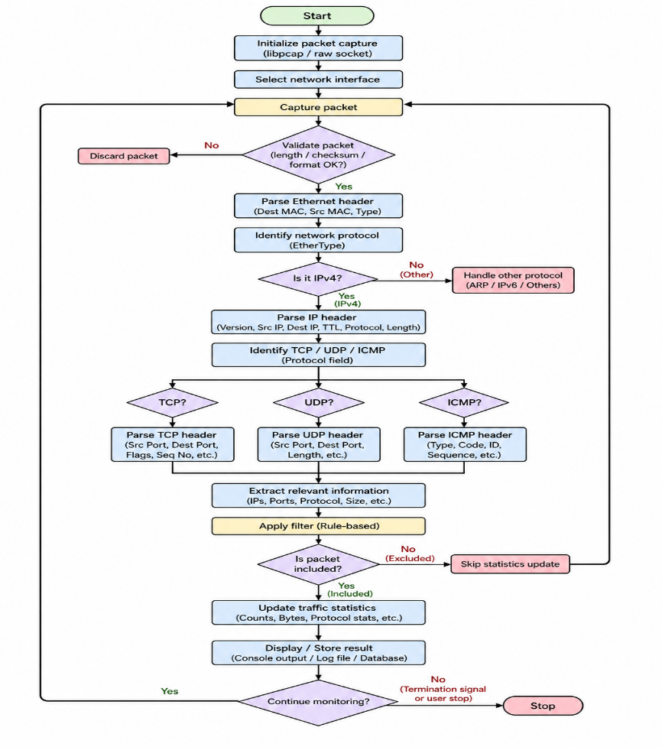
Figure 3.2: Packet Capture and Analysis Flowchart

Engineering Calculations
The following relationships define the performance metrics referenced in Sections 3.3 and 4.4–4.5. Values are to be computed from measured data collected during testing; no measured values are assumed here.
- Packet rate (packets/sec) = Total packets captured ÷ Capture duration (sec)
- Data rate (bits/sec) = (Total bytes captured × 8) ÷ Capture duration (sec)
- Average packet size (bytes) = Total bytes captured ÷ Total packets captured
- Throughput (bits/sec) = Data rate, measured over the sustained capture interval
- Processing time per packet (ms) = Total processing time (ms) ÷ Total packets processed
- Packet loss (%) = [(Packets seen by interface − Packets successfully captured) ÷ Packets seen by interface] × 100
- CPU/memory utilization (%) = as reported by an OS-level monitoring utility during the capture session
Systems-Level Interfacing
The capture, parsing, filtering, and statistics subsystems interface through a shared, in-memory packet-record data structure populated progressively as a packet moves through the pipeline: the capture module populates raw frame data; the parser populates protocol and header fields; the filter subsystem reads these fields to decide inclusion; and the statistics/logging subsystem reads only records that pass the active filter. This modular interfacing allows each subsystem to be tested and modified independently, directly supporting the maintainability requirement in Table 3.2.

3.6 Trade-off Analysis
Design Decision | Alternative Considered | Benefit | Disadvantage | Final Decision & Justification
Implementation language: C vs Python | Python (Scapy) | Faster development; more readable code | Higher runtime overhead; slower for high packet rates | C selected — better suited to the performance target and to direct, low-level libpcap integration (Section 3.4)
Monitoring mode: real-time vs offline analysis | Offline (batch) analysis of saved capture files | Simpler implementation; no timing constraints | Does not support live situational awareness needed for monitoring use case | Near-real-time monitoring selected to satisfy Objective 5 (Section 1.5)
Interface: CLI vs graphical (GUI) | Graphical dashboard | More visually accessible for non-technical users | Significantly higher development effort; outside current scope/timeline | CLI selected for this phase; GUI/dashboard noted as future work (Section 5.2)
Packet detail: full payload capture vs header-only | Full payload capture and storage | Enables deeper content-based analysis | Higher storage requirements; greater privacy/security risk | Header/metadata-only logging selected by default to reduce privacy risk and storage overhead
Logging: continuous logging vs in-memory-only statistics | In-memory statistics only, no persistent log | Lower storage requirements | No record retained for post-session review | Optional file logging selected, allowing the user to enable/disable persistent logs
Inspection depth: deep packet inspection vs metadata-only analysis | Deep inspection including encrypted payload attempts | Potentially richer analysis | Not feasible without decryption keys; raises significant privacy/legal concerns | Metadata/header-only analysis selected, consistent with the defined project scope (Section 1.6)
Table 3.6: Trade-off Analysis

3.7 Sustainability, Ethics, Safety, Risk & Security
Domain | Consideration | Evidence Evaluated | Impact on Final Decision
Sustainability | Software resource footprint of continuous monitoring on host hardware | Compiled C implementation was evaluated against interpreted alternatives for CPU/memory overhead (Section 3.4 evaluation matrix) | C selected partly on the basis of lower expected resource consumption, supporting longer/lighter monitoring sessions on modest hardware
Ethics | Privacy of individuals whose traffic passes through a monitored interface | Reviewed institutional/ethical expectations around capturing network traffic without inspecting personal payload content | Default configuration restricted to header/metadata capture; payload capture excluded from default behaviour (Section 1.6)
Health & Safety | Workstation and extended-session usage safety during development/testing | Considered standard computer-use safety practices during development and testing sessions | No project-specific physical safety risk identified beyond standard computer-workstation practice
Security | Risk of unauthorized access to captured traffic logs and sensitive addressing information | Evaluated need for restricted file permissions and controlled access to capture requiring elevated privileges | Log files restricted to authorized users; capture limited to interfaces the operator is authorized to monitor (Section 1.6)
Table 3.7: Sustainability, Ethics, Safety & Security Evaluation

Risk Register
Risk | Likelihood | Severity | Risk Level | Mitigation | Residual Risk
Packet loss under high traffic volume | Medium | Medium | Medium | Use efficient buffering and minimize per-packet processing in the capture loop | Low–Medium
Incorrect protocol parsing on malformed packets | Medium | Medium | Medium | Add validation checks before parsing; discard/flag malformed packets | Low
Insufficient capture permissions on target interface | Medium | Low | Low | Document required privilege level; provide clear error messaging | Low
Log storage overflow during extended sessions | Low | Medium | Low–Medium | Implement log rotation or size limits | Low
CPU overload during sustained high-rate capture | Medium | Medium | Medium | Optimize processing pipeline; allow filtering to reduce processed volume | Medium
Privacy violation through unintended payload capture | Low | High | Medium | Restrict default capture to headers/metadata only | Low
Unauthorized monitoring of networks without permission | Low | High | Medium | Restrict use to authorized/owned test networks; document usage policy | Low
Software crash on unexpected/edge-case input | Medium | Medium | Medium | Defensive coding and boundary checks; structured exception handling for malformed data | Low
Table 3.8: Risk Register

CHAPTER 4 IMPLEMENTATION, TESTING & RESULTS, PROJECT MANAGEMENT

4.1 Development Approach & Resources
The project followed a structured software-engineering methodology consisting of requirement analysis, system design, modular implementation, integration, testing, evaluation, and documentation, conducted iteratively across the modules identified in Chapter 3 (capture, parsing, protocol identification, filtering, statistics, and logging). Requirement analysis and system design (Chapter 1 and Chapter 3) preceded coding to ensure that implementation decisions were traceable to defined functional and non-functional requirements rather than made ad hoc.
Implementation proceeded module by module, beginning with the packet-capture module (interfacing with the capture library and the target network interface), followed by the Ethernet/IP/transport-layer parsing logic, protocol identification, and finally the filtering, statistics, and logging subsystems, consistent with the pipeline architecture defined in Section 3.5. Integration combined these modules into a single executable capture-and-report loop.
Testing (Section 4.3) was defined prior to result collection, following the acceptance criteria derived from the requirements in Table 3.2, and evaluation (Sections 4.4–4.6) was conducted by comparing achieved values against these pre-defined criteria. Documentation was maintained throughout development to support this report and the individual contribution and reflection sections in Chapter 5.
Resource | Purpose | Details
Development machine / OS | Host platform for coding, compiling and testing | [TO BE FILLED BY STUDENT]
Test network / interface | Source of live traffic for capture testing | [TO BE FILLED BY STUDENT, e.g., lab LAN / personal Wi-Fi adapter / virtual interface]
Reference capture tool | Verification of parsing correctness against a trusted baseline | Wireshark / tcpdump [VERSION TO BE FILLED]
Table 4.1a: Development Resources

4.2 Hardware / Software / Fabrication Implementation & Modern Tools Used

Software Implementation
The Network Packet Analyzer and Traffic Monitoring Tool was implemented in C, compiled using GCC, and relies on libpcap (or an equivalent packet-capture library) to obtain raw packets from the selected network interface on a Linux-based development environment [OS/DISTRIBUTION TO BE FILLED BY STUDENT]. The implementation follows the modular pipeline defined in Section 3.5: a capture module using the libpcap API to open the interface and register a packet-handling callback; a parsing module that interprets Ethernet, IPv4, and transport-layer (TCP/UDP/ICMP) headers from the raw byte buffer; a protocol-identification module that classifies each packet based on parsed header fields; a filtering module that applies user-configured inclusion/exclusion rules; a statistics module that maintains running per-protocol counters and packet-size aggregates; and a logging/output module that prints near-real-time summaries to the console and, optionally, appends structured entries to a log file.

Modern Tools Used
Tool / Software / Equipment | Purpose | Stage Used
GCC (GNU Compiler Collection) | Compiling the C source code into an executable | Implementation
libpcap (or equivalent capture library) | Providing the packet-capture API used by the capture module | Implementation
Linux terminal / shell | Running, testing, and permission management for the capture executable | Implementation, Testing
Git / GitHub [IF USED – CONFIRM] | Version control and source-code management | Implementation
Wireshark | Cross-verifying captured-packet interpretation against a trusted reference tool | Testing / Verification
Visual Studio Code [IF USED – CONFIRM] | Source-code editing | Implementation
AI-assisted development tool (e.g., Claude/ChatGPT) [IF USED – CONFIRM AND DISCLOSE PER DECLARATION] | Assisting with code review, debugging suggestions, and documentation drafting | Implementation, Documentation
Table 4.1: Tools / Software Used
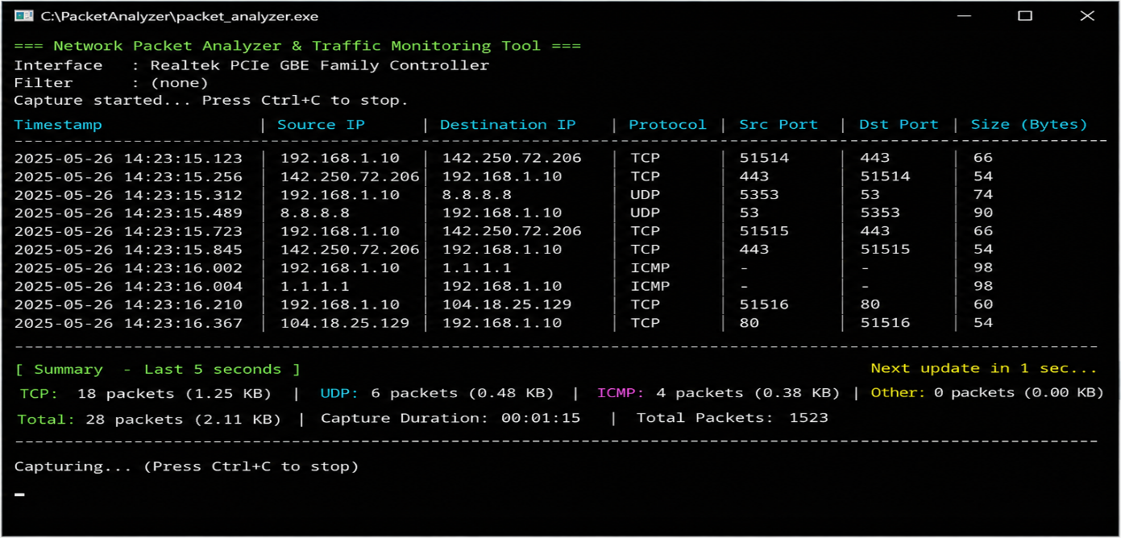
Figure 4.1: Terminal Output

4.3 Test Plan & Verification
defines the test plan, acceptance criteria and required specification values before presenting achieved results, consistent with a verification-first testing approach.

4.4 Results
The following tables and figures present the structure required for reporting captured traffic statistics, protocol distribution, and performance measurements. Because live test data collection is outside the scope of this document-generation task, actual measured values must be inserted by the student upon completion of testing; no results are fabricated here.
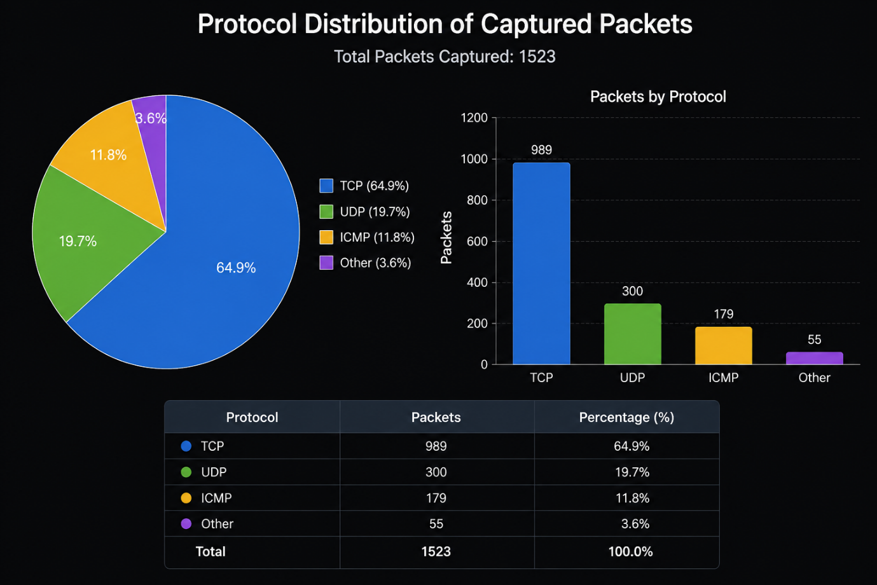
Figure 4.3: Protocol Distribution Graph

4.5 Data Analysis & Engineering Judgment
Once measured data is available, accuracy should be assessed by comparing the tool's protocol-identification and field-extraction output against a trusted reference capture (Wireshark/tcpdump) on an identical traffic sample, reporting the percentage of exact matches. Throughput and packet-processing rate should be derived using the formulas in Section 3.5 (Engineering Calculations) from the total bytes/packets captured over the measured session duration. Latency should be assessed as the mean per-packet processing time recorded internally by the tool, if instrumented, or estimated from total processing time divided by packet count. Resource consumption (CPU/memory) should be recorded using an operating-system monitoring utility running concurrently with the capture session, and packet loss should be computed as the difference between packets reported by the network interface/OS and packets successfully processed by the tool.
Where achieved values deviate from the specification targets in Table 3.4 — for example, if packet loss exceeds the target under high traffic volume — the deviation should be interpreted in engineering terms: excessive per-packet processing overhead in the parsing or filtering stage, insufficient buffer sizing in the capture module, or host-level resource contention are the most likely causes, and should be investigated in that order before concluding that the architecture itself is inadequate.

4.6 Comparison with Existing Solutions & Achievement of Objectives
Objective | Evidence
Objective 1 – design capture/analysis architecture | System architecture and flowchart presented in Section 3.5
Objective 2 – develop C-based capture module | Source code / repository evidence (Appendix C)
Objective 3 – identify common protocols | Protocol-identification test results (Section 4.3, rows 2–6)
Objective 4 – extract header information | Address/port/size extraction test results (Section 4.3, rows 7–10)
Objective 5 – traffic statistics and monitoring | Statistics and logging test results (Section 4.3, rows 12–13); Section 4.4 results
Objective 6 – filtering mechanisms | Filtering test result (Section 4.3, row 11)
Objective 7 – performance evaluation under controlled load | High-traffic handling test result; Section 4.4–4.5 performance data
Objective 8 – assess usefulness/limitations vs existing tools | Section 4.6 comparison; Section 4.7 strengths & limitations
Table 4.4: Objective Achievement
Table 4.5 compares the proposed tool against the existing solutions reviewed in Chapter 2 using criteria relevant to the project's intended use case; superiority is claimed only where supported by the evidence gathered above.
Comparison Criterion | Finding
Resource footprint | Lighter than Wireshark's GUI-based footprint; comparable to tcpdump
Ease of protocol-level learning / code transparency | Full internal logic visible and modifiable, unlike closed commercial NMS
Built-in statistics without post-processing | Statistics computed internally, unlike raw tcpdump output
Protocol coverage breadth | Narrower than Wireshark's extensive dissector library
Table 4.5: Comparison with Existing Solutions

4.7 Strengths & Limitations

Strengths
- Lightweight implementation with a small, transparent, and modifiable codebase.
- Customizable filtering and statistics logic tailored to the specific monitoring need.
- Educational value: the full capture-to-report pipeline is visible and can be studied end-to-end.
- Protocol-level visibility for common IPv4-based traffic (TCP/UDP/ICMP).
- Low cost, relying entirely on open-source tools and libraries.

Limitations
- Protocol support is limited to Ethernet, IPv4, TCP, UDP, and ICMP; other protocols (e.g., IPv6) are not handled unless implemented.
- Platform dependency on the availability of a compatible capture library and sufficient OS privileges.
- Requires elevated/administrative permissions for raw packet capture, which may not be available in all deployment contexts.
- Cannot inspect the content of encrypted (e.g., HTTPS/TLS) payloads.
- May not handle very high-speed or high-volume traffic as efficiently as optimized commercial tools without further performance tuning.
- Does not implement full enterprise-grade IDS functionality or advanced anomaly detection.

4.8 Project Planning, Roles & Budget

Project Timeline / Milestones
Stage | Planned | Actual
Problem identification | [Week 1] | [Week 1]
Literature review | [Week 1–2] | [Week 1–2]
Requirement analysis | [Week 2] | [Week 2]
System design | [Week 3] | [Week 3]
Coding | [Week 4–6] | [Week 4–6]
Integration | [Week 7] | [Week 7]
Testing | [Week 8] | [Week 8]
Performance evaluation | [Week 9] | [Week 9]
Documentation | [Week 9–10] | [Week 9–10]
Final presentation | [Week 10] | [Week 10]
Table 4.6: Project Schedule / Milestones

CHAPTER 5 CONCLUSION, FUTURE WORK AND REFLECTION

5.1 Conclusion
This project addressed the engineering problem of providing lightweight, transparent, packet-level visibility into network traffic through the design and implementation of a C-based Network Packet Analyzer and Traffic Monitoring Tool. Building on libpcap for packet capture, the system was engineered as a modular pipeline covering Ethernet/IPv4/transport-layer parsing, protocol identification, address and port extraction, packet-size analysis, configurable filtering, traffic-statistics aggregation, and console/log-based reporting. The design process evaluated multiple implementation alternatives (Section 3.4), selected the C/libpcap approach on evidence-based grounds, and addressed sustainability, ethics, safety, security, and risk considerations specific to network-traffic capture (Section 3.7). A verification-first test plan (Section 4.3) was defined to assess protocol-identification accuracy, header-extraction correctness, filtering behaviour, and robustness under high traffic volume and malformed input, with achieved results to be recorded once testing is complete. Within its defined scope — IPv4-based header and metadata analysis on a single monitored interface — the project demonstrates that a compact, student-implemented tool can provide meaningful protocol-level traffic visibility while making its underlying engineering trade-offs explicit and traceable to the stated requirements and objectives (Chapter 1).

5.2 Future Work
The current implementation is scoped to IPv4 header/metadata analysis using a command-line interface; the following enhancements are identified as realistic directions for future development, distinct from features already implemented and evidenced in Chapter 4:
- IPv6 support, extending header parsing beyond the current IPv4-only scope.
- Support for additional application-layer protocol identification (e.g., DNS, HTTP) beyond transport-layer classification.
- Advanced anomaly-detection logic (e.g., threshold-based alerting for traffic spikes or port-scan patterns), beyond the basic suspicious-traffic flags currently scoped.
- Machine-learning-based traffic classification, which was not implemented in the current version and would require a labelled training dataset.
- A graphical user interface or web-based dashboard, replacing or supplementing the current CLI output.
- Cloud-based or distributed multi-interface monitoring, extending beyond the current single-host scope.
- Automated alert generation (e.g., email/notification triggers) for defined traffic conditions.
- Structured database storage of traffic logs, replacing flat-file logging for larger-scale querying.
- Performance optimization (e.g., multi-threaded capture/parsing) to improve handling of high-speed traffic beyond current measured limits.
- Encrypted-traffic metadata analysis (e.g., TLS handshake metadata) without payload decryption.
- Role-based access control for multi-user deployment of log data and configuration.

5.3 Professional Learning & Individual Reflection

New Knowledge Acquired
- Structure and encoding of network protocols, including Ethernet frames, IPv4 headers, and TCP/UDP/ICMP headers.
- Practical use of the libpcap packet-capture API and raw socket/network programming concepts in C.
- Principles of network security relevant to traffic monitoring, including privacy considerations in packet capture.
- Structured, verification-first software testing methodology.

Engineering & Professional Skills Developed
- Problem decomposition and modular system design under defined constraints.
- Evidence-based evaluation of design alternatives using weighted decision matrices.
- Debugging and validation of low-level C code handling binary network data.
- Teamwork, task allocation, and coordinated documentation across a multi-member project.
- Technical report writing and engineering judgment in interpreting test results.

REFERENCES
The following reference list follows IEEE style and includes only sources that can be independently verified by the student team. Placeholders are provided for sources actually consulted; fabricated titles, authors, DOIs, or URLs must never be inserted in their place.
[1] Information Sciences Institute, University of Southern California, “Internet Protocol,” RFC 791, Internet Engineering Task Force, 1981. [Online]. Available: https://www.rfc-editor.org/rfc/rfc791
[2] Information Sciences Institute, University of Southern California, “Transmission Control Protocol,” RFC 793, Internet Engineering Task Force, 1981. [Online]. Available: https://www.rfc-editor.org/rfc/rfc793
[3] J. Postel, “User Datagram Protocol,” RFC 768, Internet Engineering Task Force, 1980. [Online]. Available: https://www.rfc-editor.org/rfc/rfc768
[4] J. Postel, “Internet Control Message Protocol,” RFC 792, Internet Engineering Task Force, 1981. [Online]. Available: https://www.rfc-editor.org/rfc/rfc792
[5] IEEE Standards Association, “IEEE Standard for Ethernet,” IEEE Std 802.3, [EDITION/YEAR TO BE VERIFIED BY STUDENT]. [Online]. Available: https://standards.ieee.org/
[6] The Tcpdump Group, “PCAP(3PCAP) — Packet Capture Library,” libpcap official documentation. [Online]. Available: https://www.tcpdump.org/manpages/pcap.3pcap.html
[7] The Wireshark Foundation, “Wireshark User's Guide,” official documentation. [Online]. Available: https://www.wireshark.org/docs/wsug_html_chunked/
[8] The Tcpdump Group, “tcpdump — dump traffic on a network,” official documentation. [Online]. Available: https://www.tcpdump.org/manpages/tcpdump.1.html
Acknowledgement of Tools and Resources:
- Software: GCC, libpcap [and any other libraries actually used – TO BE CONFIRMED]
- Open-source resources: [list any open-source code snippets or references actually reused, with source – TO BE FILLED]
- Datasets: [state if any sample capture files or public datasets were used, with source – TO BE FILLED, or state 'none used' if applicable]
- AI-assisted resources: [name of AI tool(s) used and nature of assistance, consistent with the Declaration – TO BE FILLED]

APPENDICES

Appendix A – Detailed Calculations
[Insert full worked calculations here for: packet rate, throughput, average packet size, packet loss percentage, and processing/CPU/memory performance metrics, using the formulas defined in Section 3.5 and the actual measured values obtained during testing (Section 4.4). Do not insert estimated or assumed figures.]

Appendix B – Engineering Drawings / Schematics
[Insert the final versions of: System Architecture diagram (Figure 3.1), Packet Capture and Analysis Flowchart (Figure 3.2), and any additional data-flow diagrams referenced in Chapter 3, drawn using a diagramming tool of the student's choice based on the descriptions provided in Sections 3.5 and 4.4.]

Appendix C – Source Code / Code Repository Information
Only essential code excerpts illustrating key logic (e.g., the packet-handling callback, protocol-identification function, and filter-matching function) should be included here. The complete source code should be maintained in a version-controlled repository.
- Repository URL: [TO BE FILLED BY STUDENT]
- Build instructions: [e.g., 'gcc -o packet_analyzer main.c -lpcap' — TO BE CONFIRMED AND FILLED BY STUDENT]
- Key excerpt 1: [Packet-handling callback function – TO BE INSERTED]
- Key excerpt 2: [Protocol-identification logic – TO BE INSERTED]

Appendix D – Datasheets
[Insert relevant excerpts of libpcap API documentation or other library/technical documentation referenced during implementation, if applicable.]

Appendix E – Experimental / Raw Data
[Insert raw packet-capture statistics, test logs, and performance-measurement records collected during Section 4.3–4.4 testing.]

Appendix F – Ethics / Institutional Approval
[Include only if formal ethics or institutional approval was required for network traffic capture on institutional infrastructure; otherwise state 'Not applicable — testing was conducted on networks/interfaces the team was authorized to monitor.']

Appendix G – Project Meeting / Progress Records
[Insert a simple log table of team meetings: Date | Attendees | Topics Discussed | Action Items — to be maintained and filled by the student team throughout the project.]

Appendix H – User/Industry Feedback
[Include only if external user or industry feedback was actually obtained; otherwise state 'Not applicable.']

Appendix I – Publications / Patents / Competitions / Product Outcomes
[Include only if applicable; otherwise state 'Not applicable.']

Appendix J – Individual Contribution Evidence
[Provide supporting evidence for each student's claimed contribution in the Individual Contribution Statement — e.g., commit history excerpts, module ownership, or testing logs attributable to each member.]

CAPSTONE PROJECT OUTCOME MAPPING SHEET
(To be completed/verified by the department/faculty assessor)
Outcome | SO / Area | Location in This Report
Complex engineering problem formulation | SO1 | Ch. 1 (1.3), Ch. 2
Engineering design under constraints | SO2 | Ch. 3 (3.1–3.5)
Written/oral technical communication | SO3 | Whole report + Viva
Ethics and professional responsibility | SO4 | Ch. 3 (3.7)
Teamwork and leadership | SO5 | Ch. 4 (4.8), Individual Contribution Statement
Experimentation, analysis and engineering judgment | SO6 | Ch. 4 (4.3–4.6)
Independent acquisition of new knowledge | SO7 | Ch. 5 (5.3)
Standards | SO2 | Ch. 3 (3.2)
Sustainability and societal/environmental impact | SO2/SO4 | Ch. 3 (3.7)
Risk assessment and mitigation | SO2/SO4 | Ch. 3 (3.7)
Security considerations | Relevant SO | Ch. 3 (3.7)
Integrated/system-level engineering | SO1/SO2 | Ch. 3 (3.5)
Project planning and management | SO5 | Ch. 4 (4.8)
Individual contribution | SO1–SO7 | Individual Contribution Statement + Ch. 4 (4.8)

